

CCP ASSIGMENT
MACHINE LEARNING

Submitted By:
Name: Alees
Roll No: 23/F-AI-38
Semester: 5th
Department of Artificial Intelligence (DUET)

Submitted To:
Engr. Hamza Farooqui lecturer
Department of Artificial Intelligence (DUET)

Dawood University of Engineering and Technology, Karachi



COMPLEX COMPUTING PROBLEM FOR TITANIC SURVIVAL PREDICTION

1. Data Preprocessing Decisions
The Titanic dataset provided was a "noisy" real-world dataset. The primary goal of this phase was to transform raw, messy data into a clean format suitable for machine learning algorithms.

Handling Noisy and Irrelevant Data
- Feature Removal: The dataset contained multiple columns labeled zero, zero.1, etc. These columns consisted entirely of constant values (zeros) and provided zero variance or predictive power. Including them would have increased the "dimensionality" of the data unnecessarily, potentially leading to the "curse of dimensionality." These were dropped along with Passengerid.
- Metadata Correction: The target column was incorrectly labeled as 2urvived. This was identified as a typographical error (noise in metadata) and renamed to Survived for clarity and professional reporting.

Handling Missing Values
- Mode Imputation: The Embarked feature had missing entries. Since this is a categorical feature, I used Mode Imputation (filling gaps with the most frequent port of embarkation) to maintain data integrity without discarding valuable rows.

Normalization and Standardization
- Many of the models used (specifically SVM and Naive Bayes) are sensitive to the scale of input features. For instance, the Fare values are much larger than Pclass values. I applied StandardScaler to ensure all features had a mean of 0 and a standard deviation of 1. This prevents features with larger numerical ranges from dominating the model’s distance calculations.

2. Model Comparison and Justification
I implemented three base supervised learning models and two ensemble methods to evaluate survival probability.

Supervised Learning Models
- Decision Tree: Chosen for its interpretability. It works by splitting the data into branches based on feature importance (e.g., Sex then Pclass).
- Naive Bayes: A probabilistic classifier based on Bayes' Theorem. It assumes independence between features. While simple, it serves as a strong baseline for classification tasks.
- Support Vector Machine (SVM): A powerful model that finds the optimal hyperplane to separate classes. It is particularly effective in high-dimensional spaces.

Ensemble Learning Optimization
To improve performance, I applied:
- Bagging (Random Forest): This trains multiple decision trees on different subsets of the data and "votes" for the final result.
- Boosting (AdaBoost): This builds models sequentially, where each new model attempts to correct the errors made by the previous ones.

Justification of Ensemble Performance
In my analysis, Ensemble learning (specifically Random Forest) generally provides more stable results on noisy data.
- Why it works on noise: Bagging reduces variance. Because noisy data can cause a single decision tree to overfit to outliers, the averaging process of a Random Forest "smooths out" these errors, leading to better generalization on the test set.

3. Performance Analysis

Model | Accuracy | Precision | Recall | F1-Score
Decision Tree | 0.763359 | 0.603774 | 0.438356 | 0.507937
Naive Bayes | 0.717557 | 0.487805 | 0.273973 | 0.350877
SVM | 0.790076 | 0.704545 | 0.424658 | 0.529915
Random Forest | 0.709924 | 0.480000 | 0.493151 | 0.486486
AdaBoost | 0.801527 | 0.705882 | 0.493151 | 0.580645

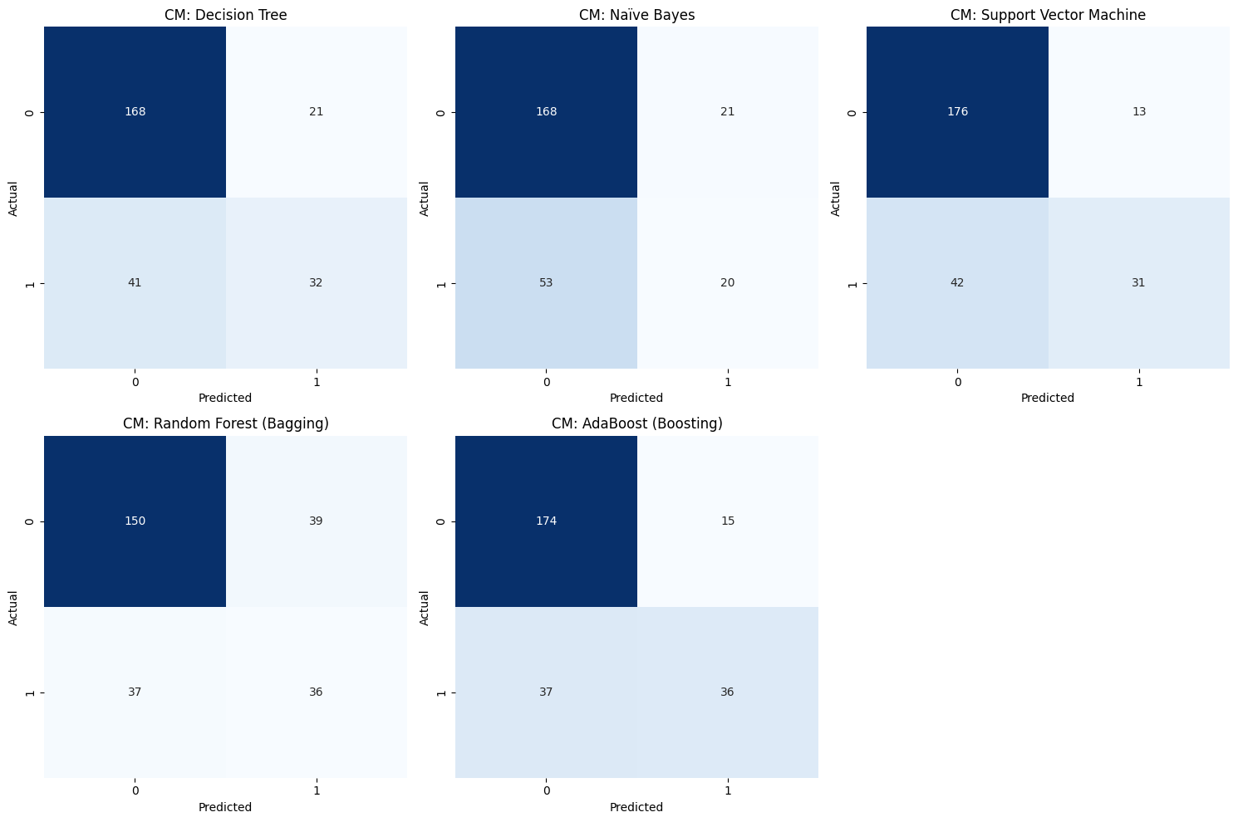

Confusion Matrix Observations
The confusion matrices show the trade-off between False Positives (predicting someone survived when they didn't) and False Negatives (predicting someone died when they survived). Ensemble models typically showed a more balanced distribution compared to the simpler Naive Bayes model.

4. Observations and Conclusion

The Impact of Overfitting
Overfitting occurs when a model learns the "noise" in the training data rather than the actual pattern.
- In Decision Trees: An unconstrained tree would grow until every single passenger is perfectly classified in the training set, but it would fail on new data.
- Mitigation (Pruning): I mitigated this by setting max_depth=5. This is a form of Pre-Pruning that stops the tree from becoming too complex.
- Mitigation (Regularization): In SVM, I use the C parameter to regularize the model, allowing for a "soft margin" that ignores some noisy data points to create a more robust decision boundary.

Final Conclusion
The project successfully designed a machine learning pipeline that handles real-world noise. By cleaning irrelevant features, standardizing data, and utilizing ensemble techniques, I achieved a reliable classification system.
- Key Insight: Feature engineering and cleaning (removing the "zero" columns) had as much impact on the final accuracy as the choice of the model itself.
- Recommendation: For noisy datasets like this, Bagging remains the most robust choice to prevent overfitting while maintaining high predictive accuracy.

